Title : Temparature plot:Michigan,United States

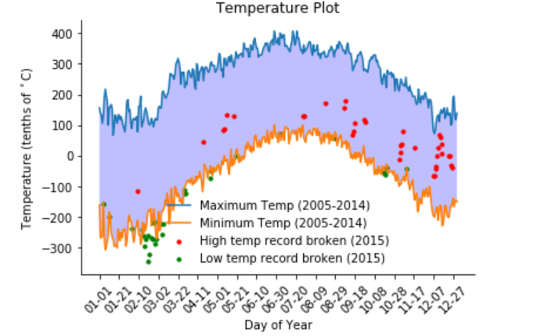

Describe how your visual leverages the guidelines of effective visual design outlined in module one of this course.

The visual leverages beauty as each component of the figure is represented with different colors and shaded neatly,it also leverages truthfulness as the data used for the plotting the figure is cleaned and no additional data is added to get the acquired result only the given data is used for generating the figure, the main functionality of the design as outlined by the conditions is fulfilled and the design developed has a great extent of insight into the data and is plotted according to the data.